**These [SQL](https://www.geeksforgeeks.org/sql-concepts-and-queries/)commands are mainly categorized into five categories:**

1. DDL – Data Definition Language
2. DQL – Data Query Language
3. DML – Data Manipulation Language
4. DCL – Data Control Language
5. TCL – Transaction Control Language

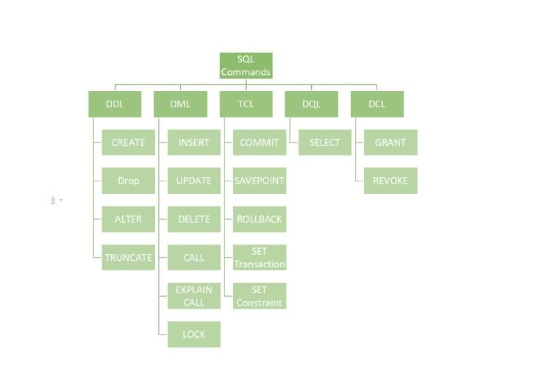

List of DDL commands:

* [CREATE](https://www.geeksforgeeks.org/sql-create/): This command is used to create the database or its objects (like table, index, function, views, store procedure, and triggers).
* [DROP](https://www.geeksforgeeks.org/sql-drop-truncate/): This command is used to delete objects from the database.
* [ALTER](https://www.geeksforgeeks.org/sql-alter-add-drop-modify/)**:**This is used to alter the structure of the database.
* [TRUNCATE](https://www.geeksforgeeks.org/sql-drop-truncate/)**:**This is used to remove all records from a table, including all spaces allocated for the records are removed.
* [COMMENT](https://www.geeksforgeeks.org/sql-comments/): This is used to add comments to the data dictionary.
* [RENAME](https://www.geeksforgeeks.org/sql-alter-rename/)**:**This is used to rename an object existing in the database.

**List of DQL:**

* [SELECT](https://www.geeksforgeeks.org/sql-select-clause/)**:**It is used to retrieve data from the database.

**List of DML commands:**

* [INSERT](https://www.geeksforgeeks.org/sql-insert-statement/): It is used to insert data into a table.
* [UPDATE](https://www.geeksforgeeks.org/sql-update-statement/)**:** It is used to update existing data within a table.
* [DELETE](https://www.geeksforgeeks.org/sql-delete-statement/): It is used to delete records from a database table.
* [LOCK:](https://www.geeksforgeeks.org/sql-lock-table/) Table control concurrency.
* **CALL:**Call a PL/SQL or JAVA subprogram.
* **EXPLAIN PLAN:** It describes the access path to data.

**List of  DCL commands:**

[GRANT:](https://www.geeksforgeeks.org/mysql-grant-revoke-privileges/)This commandgives users access privileges to the database.

**Syntax:**

*GRANT SELECT, UPDATE ON MY_TABLE TO SOME_USER, ANOTHER_USER;*

[REVOKE:](https://www.geeksforgeeks.org/difference-between-grant-and-revoke/)This command withdraws the user’s access privileges given by using the GRANT command.

**Syntax:**

*REVOKE SELECT, UPDATE ON MY_TABLE FROM USER1, USER2;*

**TCL Commands**

**BEGIN:** Opens a Transaction.

[COMMIT](https://www.geeksforgeeks.org/sql-transactions/)**:**Commits a Transaction.

**Syntax:**

*COMMIT;*

[ROLLBACK](https://www.geeksforgeeks.org/sql-transactions/)**:**Rollbacks a transaction in case of any error occurs.

**Syntax:**

*ROLLBACK;*

[SAVEPOINT](https://www.geeksforgeeks.org/sql-transactions/)**:**Sets a save point within a transaction.

**Syntax:**

*SAVEPOINT SAVEPOINT_NAME;*

**Create Table in sql**

The create table command is the DDL command for creating a table in a MySQL database. Let's understand how to create a table in SQL.

Syntax:

To create a table in SQL

**CREATE TABLE tableName(ColumnName datatype size constraint)**

Each column in a table must have a name, data type, and size (size defines the maximum length of data that a given column may carry).

Example: To create a table in SQL.

**CREATE TABLE CUSTOMER_ID(ID INT(10));**

**CREATE TABLE SALES(ID INT(10));**

The first command is creating a table name as CUSTOMER_ID having a field ID of type int and length as 10. Similarly, the second command creates a table name as SALES with field ID of type int and size as 10.

In this way, we can create a table in the SQL database.

**Alter Table**

The Alter table command is used to alter the existing table structure. For example, with the help of the alter table, we can perform the following operation easily:

----**Adding a new column to the existing table.**

----**Rename the table.**

----**Deleting the column from the existing table.**

These are some common operations we can perform using the alter table command. Let's understand these operations using examples.

**Adding a New column to the Existing table.**

We can add a new column to the table using alter table command. Let's understand the syntax for adding a new column.

Syntax:

**ALTER TABLE tableName add columnName datatype;**

Rename the Table

To rename the table, we can use alter table command. Let's understand the syntax to rename the table.

Syntax:

**ALTER TABLE old_table_name RENAME new_table_name;**

**Deleting the Column from The Existing Table.**

The syntax for deleting a particular column from the table is given below.

Syntax:

**ALTER TABLE Customers**

**DROP COLUMN ContactName;**

**Delete Table**

We can delete the table in two ways:

----Delete all records of the table without removing the table structure.

----Delete all records along with the structure of the table.

Let's understand both ways and the commands used to perform these operations.

Delete All Records of the Table Without Removing the Table Structure.

The delete command is a DML command that is used to delete all the table records by preserving the table's structure. We can also use the WHERE clause to delete particular records of the table.

The following is the syntax to delete a table in SQL.

Syntax:

**DELETE FROM TableName;**

The above syntax is used to delete all the records without any changes in the structure of the table.

**Deleting the table, student**

**DELETE FROM student;**

Delete All Records as well as the Structure of the table.

**DROP:**

The DROP command is used to delete all records as well as the structure of the table.

Let's understand the syntax of how to delete a table in SQL using the drop command.

**Syntax:**

**DROP TABLE table_name;**

This syntax is used to delete all the records and the table's structure. This is the same as the delete command, but this will not preserve the structure of the table.

**INSERT INTO :**

The **INSERT INTO** statement is used in SQL to add new records (rows) to a table. The basic syntax for the **INSERT INTO** statement is as follows:

**SYNTAX:**

INSERT INTO table_name (column1, column2, column3, ...)

VALUES (value1, value2, value3, ...);

UPDATE:

The **UPDATE** statement in SQL is used to modify existing records in a table. The basic syntax for the **UPDATE** statement is as follows:

**SYNTAX:**

UPDATE table_name

SET column1 = value1, column2 = value2, ...

WHERE condition;

**Example:**

-- Example: Updating the email address for a user with username 'john_doe'

UPDATE users

SET email = 'john.doe@example.com'

WHERE username = 'john_doe';

**Truncate Table**

The truncate table command is used to delete all the records from the table without deleting the structure of the table, but we cannot use the where clause in the truncate table command.

Let's understand the syntax of the truncate table in SQL.

Syntax:

**TRUNCATE TABLE tableName;**

The above syntax of the truncate table in SQL is used to delete the records from the table.

**Truncate Table** vs **Delete**

Truncate table Delete command

Truncate command is a DDL command. Delete command isDMLcommand.

The where clause cannot used The where clause can be used

Truncate command cannot delete any Delete command can delete particular records specific records of the table.

Truncate command is faster Delete command is slower

**Conclusion**

CREATE TABLE command is used to create the structure of the table.

TRUNCATE command is slower than the delete command.

We can rename the table name using the ALTER TABLE command.